Here is the new version of Project Thunderdome. It's mostly the same app as before, but now updated to work with Vault 2012.
It still pulls down updates.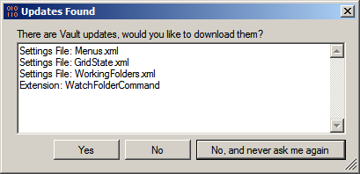
It still has the "Users Folder" concept.
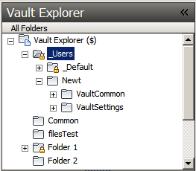
And you can still backup your settings.
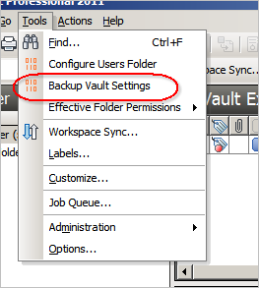
There are some minor fixes. For example, if an extension gets installed, a menu reset is performed.
If you have a Web Service event handler, Project Thunderdome can pull that down too. Vault 2012 has the concept of an Extension, which encompasses both custom commands and web service command event handlers. Thunderdome will pull down an extension, regardless of type.
Requirements:
Vault Workgroup/Collaboration/Professional 2012
Click here to download application
Click here to download source
Upgrading from Vault 2011
The settings are different from Vault 2011 and Vault 2012. So if you are pushing out settings and extensions, make sure they are synced to Vault 2012.
Likewise if you have saved settings, you will might want to clear those out and re-save with your Vault 2012 settings.

